## FOCAS Community Archives Program Internship

Instructors of record: Dr. Cecilia Salvatore and Dr. Anthony Dunbar

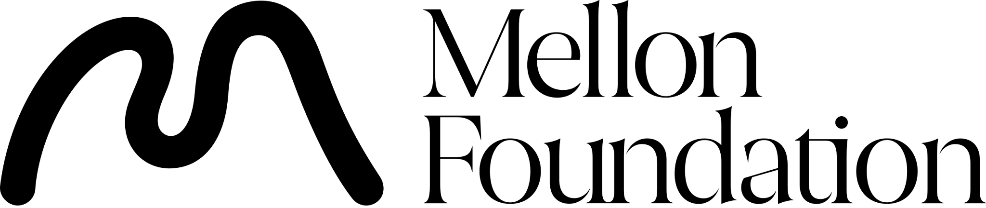

Welcome to FOCAS! This internship provides a unique opportunity to engage deeply with community archives and contribute meaningfully to their vital memory-keeping work. Over the course of the program, you will apply culturally responsive archival practices, build critical professional skills, and expand your understanding of how archives serve diverse communities.

### **Learning Objectives**

Over the course of this internship, you will:

1. Gain practical experience in archival tasks, including appraisal, arrangement, description, preservation, and digitization.
2. Develop cultural competency in working with minoritized and underrepresented communities.
3. Understand and apply ethical frameworks that prioritize community-driven decision-making in archives.
4. Collaborate with community archives to address their specific goals and needs.
5. Reflect on how your work supports the overarching mission of equitable access to cultural heritage.

### **Work Responsibilities**

As an intern, you will engage in the following activities at your assigned community archive:

#### **1. Collection Processing and Management**

* **Appraisal & Selection**: Collaborate with community stakeholders to identify materials of significance.
* **Arrangement & Description**: Organize records following community preferences, ensuring culturally appropriate descriptive practices.
* **Preservation**: Assess the physical condition of materials and implement preservation measures to extend their lifespan.

#### **2. Digitization and Digital Access**

* **Digitization Projects**: Scan or photograph items to create digital surrogates for preservation and wider access.
* **Metadata Creation**: Develop metadata aligned with community standards to enhance searchability and context.
* **Digital Asset Management**: Assist in setting up and organizing digital repositories using tools recommended by your host archive.

#### **3. Public Knowledge and Engagement**

* **Exhibition Curation**: Design physical or digital exhibitions showcasing the stories and significance of archival materials.
* **Storytelling Methods**: Use oral histories or other community-informed approaches to gather and document narratives.
* **Community Outreach**: Assist in developing programs or materials to help the community engage with the archive, such as workshops, guides, or events.

### **Reflection and Integration**

Throughout the internship, you will be encouraged to reflect on your experiences through:

* Bi-weekly journal entries connecting your work to archival theories and ethical considerations.
* An end-of the-semester presentation/discussion to share your contributions and lessons learned with the FOCAS community.

**Note:** Each community archive is unique, and your responsibilities may vary to align with the archive’s specific priorities. Flexibility, cultural sensitivity, and a collaborative mindset are critical to your success in this program.

We are excited to embark on this journey with you as you contribute to preserving and amplifying the histories of diverse communities!